Numerical methods to laser kinematics

Owen Lu

Electroimpact Inc.

owenl@electroimpact.com

*Abstract*—This document describes the method proposed to solve for the laser kinematic system and translational/rotational transforms. It is done in a purely numerical fashion and tested on theoretical models for which the solution is known.

# Introduction

At the core of finding the rotation and translation of the laser reference frame in respect to the absolute reference frame, ray equations must be solved. Loosely speaking, the simplified problem has a set of 4 or more angle pairs $θ_{1},θ_{2}$ describing mirror angles and known calibration points $\overline{x}$. The ray created by configuration $θ_{1},θ_{2}$ is assumed to pass through $\overline{x}$ for some $q,T$. It is important to know that the solution to $q$ is not unique.

# Objective formulation

In experience, the laser projectors solving method gives results that depend greatly on the order in which points are registered. This is not ideal since consistent results are unable to be realized. Furthermore, there should be a “best” solution that gives the least error possible, and the operator should not need to permute calibration points to find this best solution.

Sum of squared angular error in this case is the metric that is proposed to equally weight all points. We suppose that the laser projector coordinates lie at ${\overline{x}}_{0}$ with rotation $q$ then we calculate the all rays $r$ that would result from $\overline{θ}$. At this point $n$ lines are created and we can calculate the minimum distance between $x_{i}$ and $r_{i}$. This distance is squared and summed as the objective metric.

Mathematical equation is shown below.



# Plane geometry

The construction of the system is such that an easy choice of a coordinate frame can be made.

Two rotational axes ${\overline{v}}_{1},{\overline{v}}_{2}$ of the mirrors are orthogonal, to one another. The laser is also parallel to ${\overline{v}}_{2}$.

Thus, we can select laser vector $\overline{u}$ to be along the x-axis

|  |  |  |
| --- | --- | --- |
|  | $$\overline{u}={(\begin{matrix}1 & 0 & 0\end{matrix})}^{T}$$ | (1) |

As a simplification the first plane is assumed to have no thickness, normal ${\overline{n}}_{1}$ and rotates about the line $L_{1}$ which is parallel to the z-axis.

|  |  |  |
| --- | --- | --- |
|  | $$L_{1}:\left(\begin{matrix}x_{1} \\ y_{1} \\ 0\end{matrix}\right)+λ_{1}\left(\begin{matrix}0 \\ 0 \\ 1\end{matrix}\right)={\overline{x}}_{1}+λ_{1}{\overline{e}}_{3}$$ | (2) |

In Figure 1 this virtual plane represents a mirror plane of zero thickness and will be corrected for later in the model. The normal to the plane can be written in terms of $θ_{1}$.

|  |  |  |
| --- | --- | --- |
|  | $${\overline{n}}_{1}=\left(\begin{matrix}-sin⁡(θ_{1}) \\ cos⁡(θ_{1}) \\ 0\end{matrix}\right)$$ | (3) |

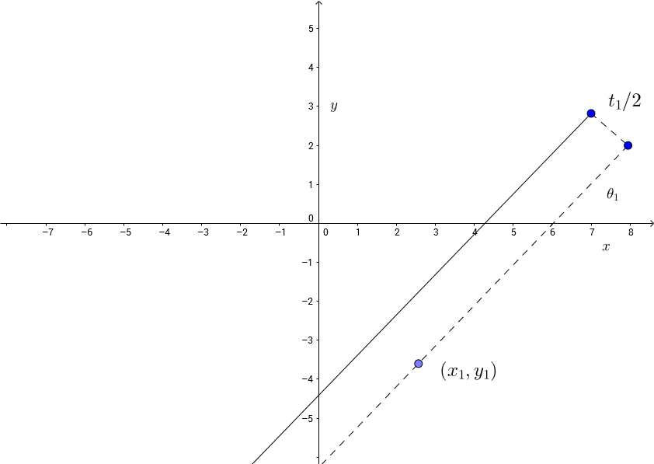

Figure 1 – Defined plane geometry in $xy$ plane view

Therefore the mirror plane can be defined by a dot product expression.

|  |  |  |
| --- | --- | --- |
|  | $$\left(\overline{x}-{\overline{x}}_{1}\right)⋅{\overline{n}}_{1}=0$$ | (4) |

Now that the expression for the zero thickness plane is developed, an offset plane can also easily formulated. This offset plane will be shifted by half the mirror thickness $t_{1}$.

This can be done easily by substituting ${\overline{x}}_{1}$ for ${\overline{x}}_{1}+\frac{t_{1}}{2}{\overline{n}}_{1}$. Distributive law can then be applied to the dot product.

|  |  |  |
| --- | --- | --- |
|  | $$\overline{x}⋅{\overline{n}}_{1}={\overline{x}}_{1}⋅{\overline{n}}_{1}+\frac{t_{1}}{2}$$ | (5) |

Similarly, the same method can be applied to describe the second mirror plane, with normal ${\overline{n}}_{1}$ rotating about $L_{2}$ parallel to the x-axis. The diagram would be exactly the same as Figure 1 but with $z$ replacing the ordinate and $y$ replacing the abscissa.

|  |  |  |
| --- | --- | --- |
|  | $$L_{2}:\left(\begin{matrix}0 \\ y_{2} \\ z_{2}\end{matrix}\right)+λ_{2}\left(\begin{matrix}1 \\ 0 \\ 0\end{matrix}\right)={\overline{x}}_{2}+λ_{2}\left(\begin{matrix}1 \\ 0 \\ 0\end{matrix}\right)$$ | (6) |
|  | $${\overline{n}}_{2}=\left(\begin{matrix}0 \\ -sin⁡(θ_{2}) \\ cos⁡(θ_{2})\end{matrix}\right)$$ | (7) |
|  | $$\overline{x}⋅{\overline{n}}_{2}={\overline{x}}_{2}⋅{\overline{n}}_{2}+\frac{t_{2}}{2}$$ | (8) |

# Ray Reflection transformation

In order to find the ray emanating from the second mirror surface, the laser vector $\overline{u}$ must undergo two reflection transformations.

To find reflected vector $\overline{r}$ to input vector $\overline{d}$ reflected across plane of unit normal $\hat{\overline{n}}$, we can use the below equation.

|  |  |  |
| --- | --- | --- |
|  | $$\overline{r}=\overline{d}-2\left(\overline{d}⋅\hat{\overline{n}}\right)\overline{n}$$ | (9) |

Let $\overline{u}'$ denote the ray vector after the first planar reflection

|  |  |  |
| --- | --- | --- |
|  | $${\overline{u}}^{'}=\overline{u}-2\left(\overline{u}⋅{\overline{n}}_{1}\right){\overline{n}}_{1}$$ | (10) |

Let ${\overline{u}}^{''}$ denote the ray vector after the second planar reflection

|  |  |  |
| --- | --- | --- |
|  | $${\overline{u}}^{''}=\overline{u'}-2\left(\overline{u}'⋅{\overline{n}}_{2}\right){\overline{n}}_{2}$$ | (11) |

At this point since $\overline{u}''$ can be calculated, we only need point $\overline{p}$ the point where the laser intersects the second plane.

# Finding Laser-Mirror intersection

Since the laser originates on the x-axis we can generate a line $R_{1}$.

|  |  |  |
| --- | --- | --- |
|  | $$R_{1}:s_{1}\overline{u}$$ | (12) |

Substitution of $\overline{x}=s_{1}\overline{u}$ allows us to solve $s_{1}$

|  |  |  |
| --- | --- | --- |
|  | $$s_{1}=x_{1}-y_{1}\cot\left(θ_{1}\right)+\frac{t_{1}}{2\sin\left(θ_{1}\right)}$$ | (13) |

Therefore, the point $\overline{p}'$ which is the intersection of the laser and the first mirror plane is given below.

|  |  |  |
| --- | --- | --- |
|  | $$\overline{p}'=\left(\begin{matrix}x_{1}-y_{1}\cot\left(θ_{1}\right)-\frac{t_{1}}{2\sin\left(θ_{1}\right)} \\ 0 \\ 0\end{matrix}\right)$$ | (14) |

Then the line used to find the intersection of the laser line and the second mirror is using line $R_{2}$ and the second mirror plane.

|  |  |  |
| --- | --- | --- |
|  | $$R_{2}:{\overline{p}}^{'}+s_{2}\overline{u}'$$ | (15) |

Substitute $\overline{x}={\overline{p}}^{'}+s_{2}\overline{u}'$ and solve for $s_{2}$

|  |  |  |
| --- | --- | --- |
|  | $$s_{2}=\frac{\left(y_{2}-z_{2}\cot\left(θ_{2}\right)-t_{2}/2\right)}{\sin\left(2θ_{1}\right)}$$ | (16) |
|  | $$s_{2}{\overline{u}}^{'}=\left(\begin{matrix}\left(y_{2}-z_{2}\cot\left(θ_{2}\right)-\frac{t_{2}}{2\sin\left(θ_{2}\right)}\right)\cot\left(2θ_{1}\right) \\ \left(y_{2}-z_{2}\cot\left(θ_{2}\right)-\frac{t_{2}}{2\sin\left(θ_{2}\right)}\right) \\ 0\end{matrix}\right)$$ | (17) |
|  | $${\overline{p}}^{''}={\overline{p}}^{'}+s_{2}{\overline{u}}^{'}$$ | (18) |

The last point on the $z=k$ plane can be solved by using line $R_{3}$.

|  |  |  |
| --- | --- | --- |
|  | $$R_{3}: {\overline{p}}^{''}+s_{3}\overline{u}''$$ | (19) |

Solving for $s_{3}$ such that $z=k$ allows for the final point to be found.

Since $\overline{p}''$ has no $z$ components, we simply use the equation

|  |  |  |
| --- | --- | --- |
|  | $$s_{3}=\frac{k}{\sin\left(2θ_{1}\right)\sin\left(2θ_{2}\right)}$$ | (20) |
|  | $$s_{3}{\overline{u}}^{''}=k\left(\begin{matrix}\cot\left(2θ_{1}\right)/\sin\left(2θ_{2}\right) \\ \cot\left(2θ_{2}\right) \\ 1\end{matrix}\right)$$ | (21) |

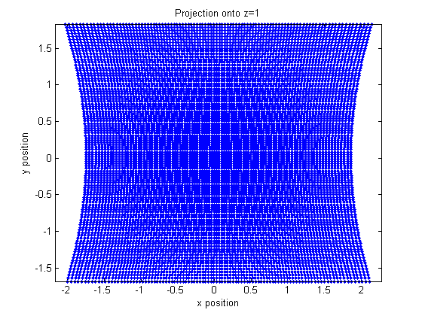

Figure 2 – Projection points using $30<θ_{1},θ_{2}<60$

Therefore, the final equation describing a projection on plane $z=k$ can be written below:

|  |  |  |
| --- | --- | --- |
|  | $$\overline{P}={\overline{p}}^{'}+s_{2}{\overline{u}}^{'}+s_{3}\overline{u}''$$ | (22) |

# Verification

Using Solidworks 3D sketches and work planes, the modelled system can be constructed to verify the calculations. Calculations using parameters matched by the Solidworks model have been verified to be exact matches.

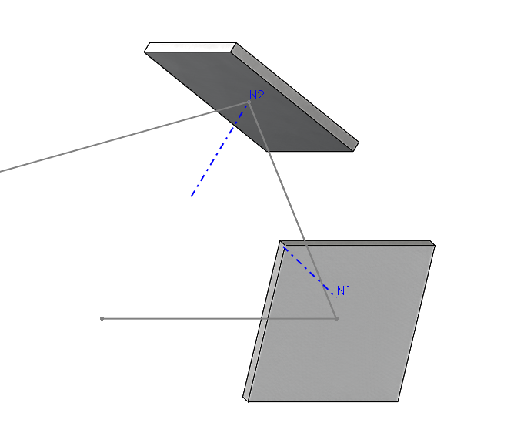

Figure 3 – Ray reflection solid model for verification